Name: A. Reddy Sulochana
Reg.No: 192372370

Exp.No.11 Map Coloring using CSP
01.08.26

Aim:
To implement the Map Coloring problem using Constraint Satisfaction Problem (CSP).

Algorithm:
- Start the program.
- Define the map with states and their neighboring states.
- Define the available colors.
- Create an empty dictionary to store color assignments.
- Select one state at a time.
- Assign a color that is different from all neighboring states.
- If no valid color is available, backtrack and choose another color.
- Repeat the process until all states are assigned valid colors.
- Display the final color assignment and stop the program.

Program:
states = input("Enter states: ").split()
neighbors = {}
for state in states:
neighbors[state] = input(f"Enter neighbors of {state}: ").split()
colors = input("Enter colors: ").split()
assignment = {}
def color_map(index):
if index == len(states):
return True
state = states[index]
for color in colors:
valid = True
for n in neighbors[state]:
if assignment.get(n) == color:
valid = False
break
if valid:
assignment[state] = color
if color_map(index + 1):
return True
assignment.pop(state)
return False
color_map(0)
print("\nColor Assignment")
for state in states:
print(state, ":", assignment[state])

Input:
Enter states: A B C D
Enter neighbors of A: B C
Enter neighbors of B: A C D
Enter neighbors of C: A B D
Enter neighbors of D: B C
Enter colors: Red Green Blue

Output:
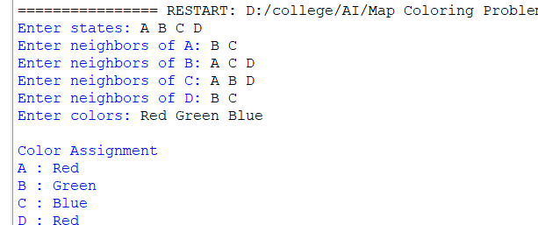

Result:
Thus, the Python program to implement the Map Coloring Problem using CSP was implemented successfully.

